DAAD Agri-Alumni-Net_Travelling workshop flyer_16th February_v1.docxgriculture is one of the main contributors of economic growth in Africa. In fact, Africa is seen to be at its turning
point and emerging as one of the fastest growing developing regions in the world, registering economic growth
levels ranging from 2% - 11% per annum and hosting some of the world’s fastest growing economies, in spite of
challenging global macro-econom

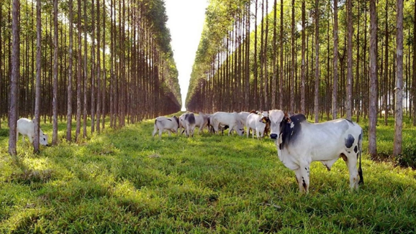
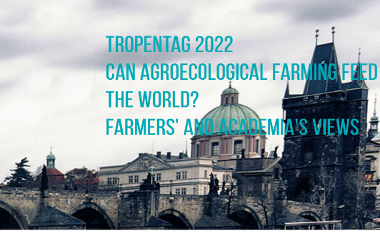

DAAD Agriculture-Alumni Network - Workshop
‘Integrating Systems for Sustainable Agricultural Intensification’

11th – 17th September 2022 - Hohenheim – Prague
Program

Saturday, 10th September 2022
Time | Activity | Notes
All day | Arrival and check-in to Ev. Tagungsstätte Birkach Grüninger Str. 25  70599 Stuttgart  Door code: C6318F | We will provide taxi service for the group arriving at 14:25 (13 of you will be onboard the same flight TK 1703)  All others should take individual taxis from the airport and keep the receipt for later reimbursement
18:00 – 19.30 | Welcome dinner at hotel | - Dinner ends at 19:30  - After 19:30, only cold food would be available

Sunday, 11th September 2022

Time |  | Activity | Notes
07:30 – 8:30 |  | Breakfast at hotel
8:45 – 9:00 |  | Bus arrival at hotel
9:00 –10:00 |  | Drive to Münsingen, Magolsheim, Hirschstr.
10:00 –13:00 |  | Sightseeing at Biosphere GeoPark, (Guided tour in military area over the Hardt to the Falkenstein tower – a former observation tower. For years Kolkraben (birds) have settled including red kites). | Topics along the tour: traditional open landscape, transhumance / sheep farming / landscape conservation, mixed forest typical for the Alps, calcareous meadows, karst landscape.  - Please come with comfortable hiking shoes, the military area does not allow open shoes such as sandals, flip flops  - Warm clothes, raincoats and umbrellas
13:30-14:00 |  | Drive to Beuren
14:00 -16:00 |  | Lunch and farm excursion at Haldenhof (Powerpoint presentation of the farm and tour to the cow barn to see automatic milking system) | Vesper buffet: homemade sausages, cheese, bread and side dishes from and at the farm
16:00 – 16:30 |  | Drive to Metzingen
16:30-18:00 |  | Vineyard excursion with wine tasting in Metzingen
18:00 – 20:30 |  | Dinner at Naturfreundehaus Falkenberg Metzingen | Traditional kitchen: Salads, Maultaschen, Spätzle, Schnitzel, Käseknödel etc
Monday, 12th September 2022
Time | Activity |  | Notes
07:30 - 08:30 | Breakfast at hotel
08:30 | Departure from hotel to Uni-Hohenheim |  | * Katrin will pick guests up at the hotel
8:45 | Registration at HS20
9:00 | Opening remarks and Welcome:  UoH and Afrika Program: Prof. Dr. Mizeck Chagunda (Managing director Hans Ruthenberg Institute and Head of the Department of Animal Breeding and Husbandry in the Tropics and Subtropics)  Spotlight on Alumni at UoH: Juliane Stoye (Hohenheim Alumni Office)
09:30 - 10:00 | Keynote speech: Prof. Dr. Regina Birner (Chair Institute of Social and Institutional Change in Tropics and sub tropics)  + Q&A session
10:00 -10:30 | Tea and coffee break
10:30 – 13:00 | Guided discussion / planning workshop  - Continuation of webinar presentations  - Priority setting for hot topics to address in the Prague workshop  - Allocation of tasks to collect information on decoding agroecology based on expertise throughout the Hohenheim and Prague program |  | * Webinar 1: 31st August  * Webinar 2: 7th September (approx. 10 5-minute presentations on agroecology, diversity and areas of expertise)
13:00 – 14:00 | Lunch at Uni-Hohenheim Mensa |  | * Each participant will be given a voucher
14:00 – 18:00 | Hohenheim farm tours  - Meiereihof (with translation)  - Kleinhohenheim
18:30-19:30 | Dinner at TMS
20:00 | Social night with music at TMS |  | Open to all Alumni and Hohenheim students
Tuesday, 13th September 2022
Time | Activity |  | Notes
07:30 - 08:00 | Breakfast at hotel |  | - 1 Bus shuttle booked to pick up luggage from hotel
09:00 | Workshop preparation for Prague in HS20 |  | - World Café arrangements and finalization of key topics and questions for discussion
11:00 | Tea and coffee (collect lunch packs and snacks for the bus journey) at HS20
11:45 - 12:00 | Assemble by Uni-Hohenheim Bus stop
12:00 - 19:30 | Departure to Prague |  | We will be travelling with other Tropentag participants from Uni-Hohenheim
19:30 - 21:00 | Arrival in Prague and check-in to  accommodation
21:00 | Dinner |  | * 60,00 EUR per diem to each participant for 6 meals

Wednesday, 14th September 2022
Time | Activity | Notes
07:30 - 08:30 | Breakfast in Prague
09:00 - 12:00 | Pre-conference workshop (WS 13) at Tropentag 2022 in Prague. “Decoding agroecology - a guiding concept for sustainable transition of African agricultural systems”? | - Obligatory for all DAAD Alumni’s  - Workshop based on the two webinars attended by Alumni – open to other Tropentag candidates
12:00 -1 3:00 | Lunch | Individually organized - Meal 2
13:00 - 17:00 | Tropentag Conference (check Tropentag program)
18:00 …. | Dinner | Individually organized - Meal 3
18:30-22:00 | Tropentag Social gathering (check Tropentag program)
Thursday, 15th September 2022
Time | Activity | Notes
07:30 - 09:00 | Breakfast
 | Tropentag all day (check Tropentag program)
12:00 - 14:00 | Lunch | Individually organized - Meal 4
19:30 | Dinner (Tropentag Official Dinner)
Friday, 16th September 2022
Time | Activity | Notes
07:30 - 09:00 | Breakfast
09:00 - 13:30 | Tropentag
13:30 - 14:15 | Lunch | Individually organized - Meal 5
14:20 | Assemble by the bus
14:30 | Departure to Stuttgart
21:30 | Arrival in Stuttgart
 | Dinner | Individually organized - Meal 6  Pick up a warm snack at service station

Saturday, 17th September 2022
Time | Activity | Notes
07:30 – 9:00 | Breakfast at hotel
09:30 - 10:30 | Strategy workshop part I at HS20  Evaluation of the status quo, collection of feedback and suggestions on the networking activities in the AgriAlumniNet
10:30 – 10:45 | Coffee break and reimbursements
10:45 – 13:00 | Strategy workshop part II at HS20  Preparation of an application for a national alumni association
13:00 – 14:00 | Lunch at beer garden of Wirtshaus Garbe
14:15 – 15:30 | Feedback session at HS20 | Form for feedback for entire workshop including Tropentag
19:30 - onwards | Dinner at Restaurant Wirtshaus Garbe
Sunday, 18th September 2022
Time | Activity | Notes
All day | Departure to home countries | Taxi will be organized for group departure and individual airport trip will already be paid for during reimbursement

Agri-Alumi-Net is funded by:

